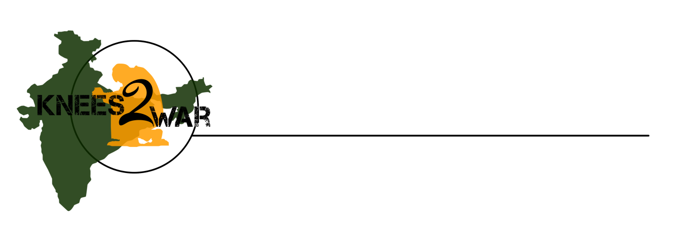

Enid, OK

5K & 1Mile Walk/ Run

Touch India Ministries

***www.knees2war.org***

February 22, 2014

Dear Community Partner:

Thank you so much for your support of the Knees 2 War Events! The money raised from the 2013 efforts was used to complete the top floor of the Thomas Memorial English School in Nelemangala, India. (See pictures below!)

The 2014 3rd Annual Knees 2 War Event will be held in downtown Enid, OK, at the Convention Center on **Saturday, April 5, 2014 at 9:00am**. This event will continue to raise funds to help Touch India Ministries support the physical and spiritual needs of children near Bangalore, India.

*Please see the attached form as you consider partnering with us again through sponsorship of this event.*

Sincerely,

Linda Kodesh

Race Coordinator

580.716.0662

linda.knees2war@gmail.com

Event Location: Enid, OK- Convention Hall, 301 South Independence

Date: Saturday, April 5, 2014

Time: Event Day Registration 7:30am- 8:45am

(1 Mile Run/Walk begins at 9:00am; 5K Run/Walk begins at 9:30am)

**Online Registration: www.knees2war.org**

Dear Community Partner:

Thank you so much for your support of the Knees 2 War Events! The money raised from the 2013 efforts was used to complete the top floor of the Thomas Memorial English School in Nelemangala, India. (See pictures below!)

The 2014 3rd Annual Knees 2 War 5K/1 mile Race will be held in downtown Enid, OK, at the Convention Center on **Saturday, April 5, 2014 at 9:00am**. This event will continue to raise funds to help Touch India Ministries support the physical and spiritual needs of children near Bangalore, India.

*Please see the attached form as you consider partnering with us again through sponsorship of this event.*

Sincerely,

Linda Kodesh

Race Coordinator

580.716.0662

linda.knees2war@gmail.com

Event Location: Enid, OK- Convention Hall, 301 South Independence

Date: Saturday, April 5, 2014

Time: Event Day Registration 7:30am- 8:30am

(1 Mile Run/Walk begins at 9:00am; 5K Run/Walk begins at 9:30am)

Online Registration: www.knees2war.org

Dear Community Partner:

Thank you so much for your support of the Knees 2 War Events! The money raised from the 2013 efforts was used to complete the top floor of the Thomas Memorial English School in Nelemangala, India. (See pictures below!)

The 2014 3rd Annual Knees 2 War 5K/1 mile Race will be held in downtown Enid, OK, at the Convention Center on **Saturday, April 5, 2014 at 9:00am**. This event will continue to raise funds to help Touch India Ministries support the physical and spiritual needs of children near Bangalore, India.

*Please see the attached form as you consider partnering with us again through sponsorship of this event.*

Sincerely,

Linda Kodesh

Race Coordinator

580.716.0662

linda.knees2war@gmail.com

Event Location: Enid, OK- Convention Hall, 301 South Independence

Date: Saturday, April 5, 2014

Time: Event Day Registration 7:30am- 8:30am

(1 Mile Run/Walk begins at 9:00am; 5K Run/Walk begins at 9:30am)

Online Registration: www.knees2war.org

Dear Community Partner:

Thank you so much for your support of the Knees 2 War Events! The money raised from the 2013 efforts was used to complete the top floor of the Thomas Memorial English School in Nelemangala, India. (See pictures below!)

The 2014 3rd Annual Knees 2 War 5K/1 mile Race will be held in downtown Enid, OK, at the Convention Center on **Saturday, April 5, 2014 at 9:00am**. This event will continue to raise funds to help Touch India Ministries support the physical and spiritual needs of children near Bangalore, India.

*Please see the attached form as you consider partnering with us again through sponsorship of this event.*

Sincerely,

Linda Kodesh

Race Coordinator

580.716.0662

linda.knees2war@gmail.com

Event Location: Enid, OK- Convention Hall, 301 South Independence

Date: Saturday, April 5, 2014

Time: Event Day Registration 7:30am- 8:30am

(1 Mile Run/Walk begins at 9:00am; 5K Run/Walk begins at 9:30am)

Online Registration: www.knees2war.org

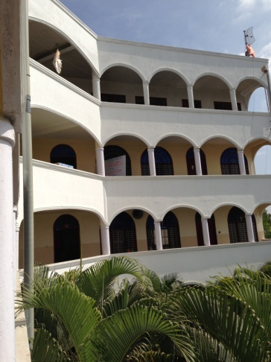

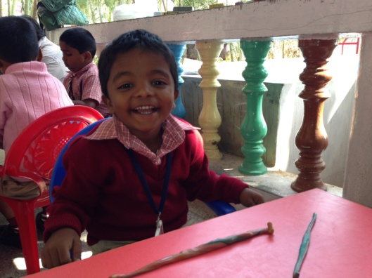

Enid, OK

April 5, 2014

Sponsorship Form

***www.knees2war.org***

We are proud to support Knees 2 War to benefit the children of Touch India Ministries. We are requesting our corporate name on all materials consistent with our sponsorship below.

*\*Sponsors will be recognized during event day activities, and their corporate name will appear on the Knees 2 War website, race sack flyers, and in a post-event article in the local newspaper. Order of listing and lettering will be consistent with sponsorship level, with the highest levels receiving the first listings and largest lettering.*

___ **Platinum Sponsor $1,000** **or more**

___ **Gold Sponsor $500**

___ **Silver Sponsor $250**

___ **Bronze Sponsor $100**

Name: _____________________________________________________________

Company: __________________________________________________________

Address: ___________________________________________________________

City: _____________________________State: ____ Zip: ____________________

Phone: _____________________E-mail: _________________________________

Enclosed is my check for $____________made payable to **Touch India Ministries**.

*\*Sponsors may also provide promotional materials to be placed in race day sacks for participants and have the option to set up a display table on the day of the event.*

___I will set up a display table on the event day. ___ I will NOT set up a display table.

___I would like to provide materials for the race day sacks distributed to the participants.

**For guaranteed placement of name on promotional items, the deadline for sponsorship is March 29, 2014.**

**Please return this form to:**

Knees 2 War/ Sponsor

Attn: Linda Kodesh

1111 S. Oakwood Rd, Apt. 1506

Enid, OK 73703